##### A

**Project Report On**

### PRIME SYNTHETIC WEBSITE

##### In Partial Fulfilment Of

**Master of Computer Applications (M.C.A)**

** J G University (2025)**

##### Developed By:

Aditya Khatri [241029]

Palak Chakrani [241008]

Rajal Sarvaliya [241093]

**(Sem-III Master of Computer Applications)**

**Index**

1. **Finalized Project Title**
2. **Project Definition………………………………………………..**
3. **Problem Statement**
4. **System Analysis ………………………………………………….**
5. **Study of Existing System and Its Limitations………………….**
6. **Proposed System with Functionalities………………………….**
7. **List of Modules and Sub-modules………………………………**

* **User Module**
* **Admin Module**
* **Product Module**
* **Backend API Module**
* **Email Module**
* **Payment Module**

**8.Technical Specifications………………………………………….**

**9.System Design & Database Development…………………………**

**10.Prepare UML Diagram………………………………………….**

* **DFD Level 0-1**
* **USECASE Diagram**
* **Class Diagram**
* **Activity Diagram**

**11.Create Data Dictionary …………………………………………**

**1.Finalized Project Title**:

* **Prime Synthetic** – MERN Stack website with JWT Auth, OTP Verification, and Admin Panel

**2.Project Definition:**

* This project is an E-commerce shopping website made using the MERN stack (React.js, Node.js, SQL).
* It allows users to log in, browse products, place orders, and make payments online. The admin can manage products, categories, and orders.

**3.Problem Statement:**

* Many e-commerce platforms lack integrated, secure authentication with features like OTP verification, admin control, and modular product/category management.

**4.System Analysis:**

* The system will be a e-commerce platform using the MERN stack (React, Node.js,SQL).
* It supports user login, JWT-based secure authentication, password recovery with Number verification
* admin management panel, product uploads and categorization.

**5.****Existing System and Limitations:**

* Product listings (with images, prices, specifications)
* Add to cart, checkout, and payment gateway integration
* Basic SMS notifications
* Customer Support Usually via phone
* No support for B2B pricing, MOQ (Minimum Order Quantity), or custom size/shape selections.
* No support for B2B invoicing or GST-compliant billing

**6.Proposed System with Functionalities:**

* User authentication with JWT & OTP
* Password reset system
* Product/category management
* Admin interface for content control
* Product search functionality
* Email integration via Resend API

**7.List of Modules and Sub-modules:**

**1. User Module** - Login   
 - Email verification via Number  
 - Password Reset **2. Admin Module** - Admin authentication  
 - Add/Update/Delete Products  
 - Manage Categories

**3. Product Module  
 -** View/Search Products  
 - Product filtering by category

**4. Backend API Module**  - JWT authentication   
 - Role-based access  
 - SQL CRUD APIs

**5. Email Module** - Number verification via Resend API

**6. Payment Module** - Online payment

**8.Technical Specifications**

|  |  |
| --- | --- |
| Component | Technology / Tool Used |
| Frontend | React.js |
| Backend | Node.js |
| Authentication | JWT (Access & Refresh Tokens), Number-based via email |
| Email API | Resend |
| Payment | Online |
| Development Tools | VS Code, GitHub |

**9. System Design & Database Development**

* **Registration Page**

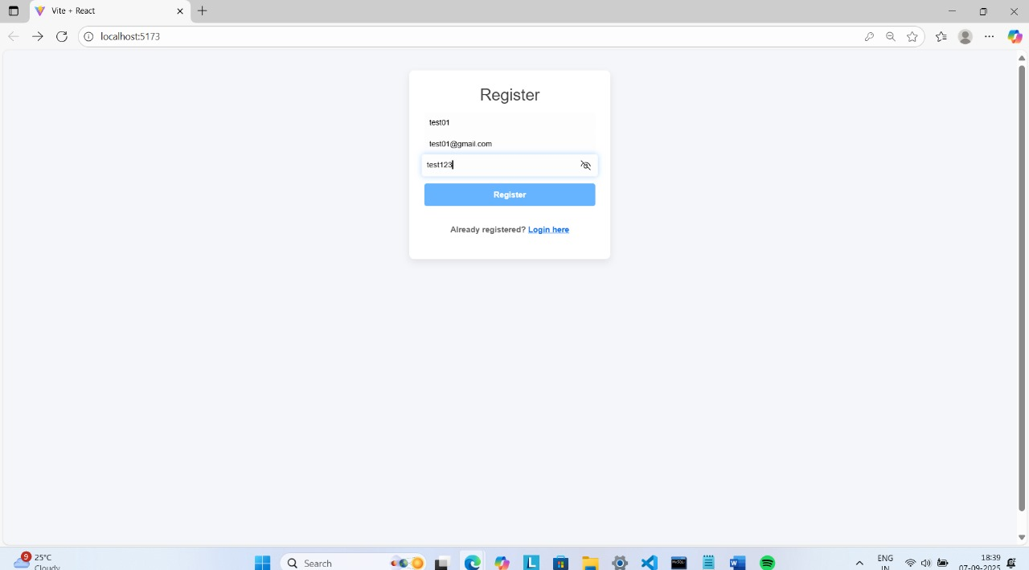

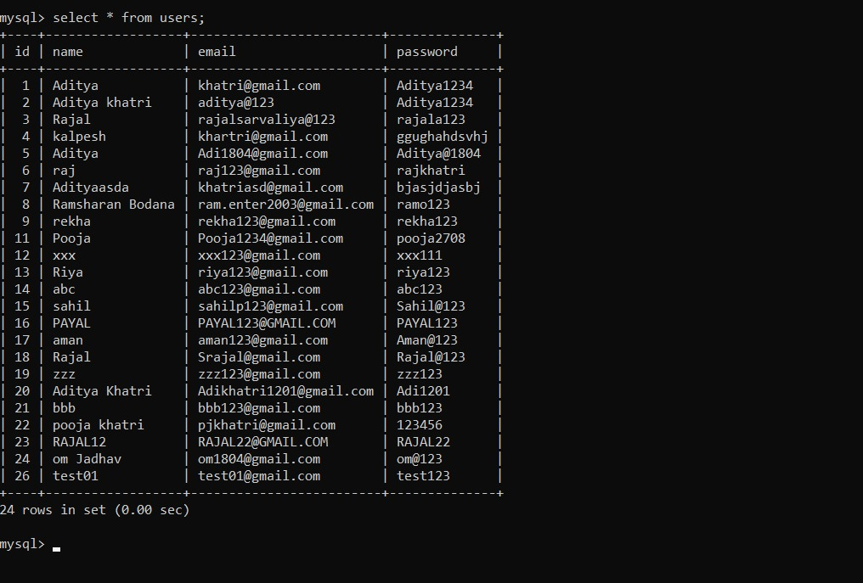

2.Login Page

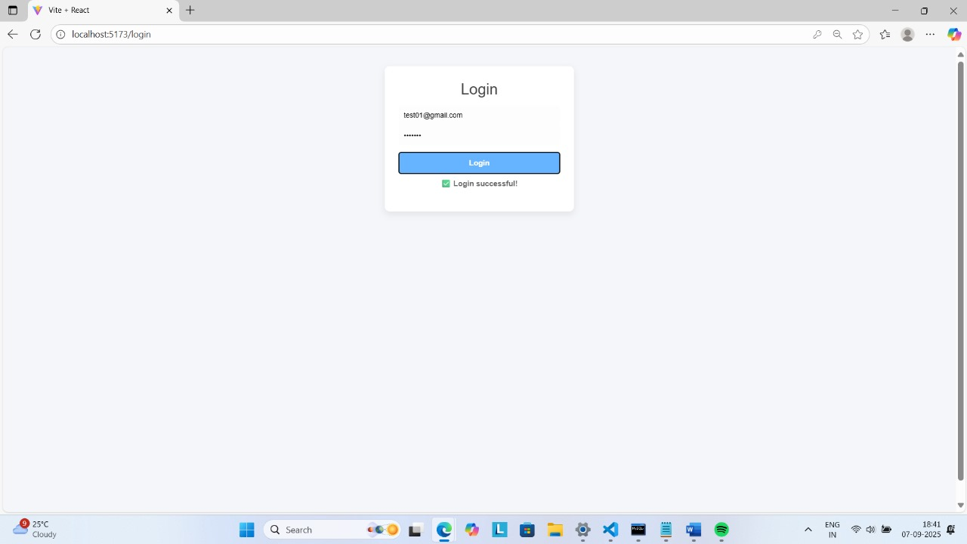

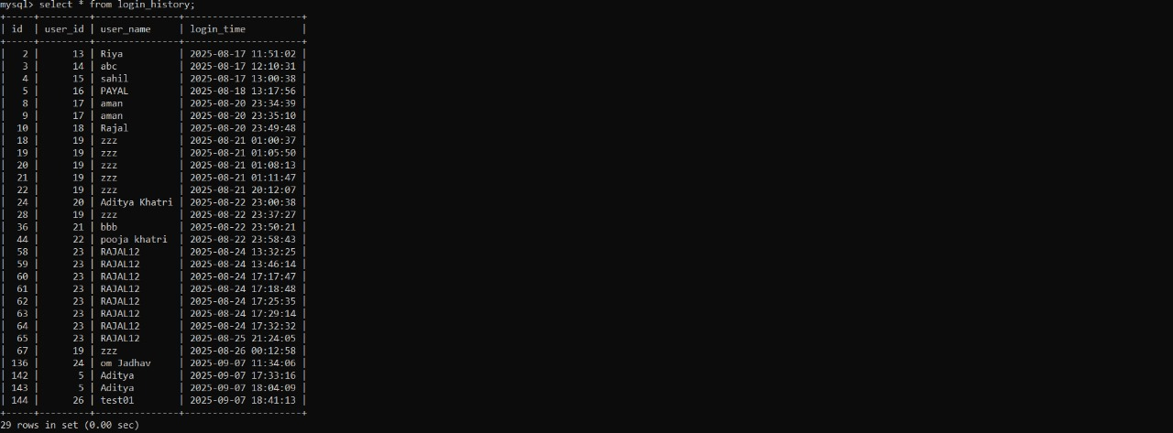

3.Home page

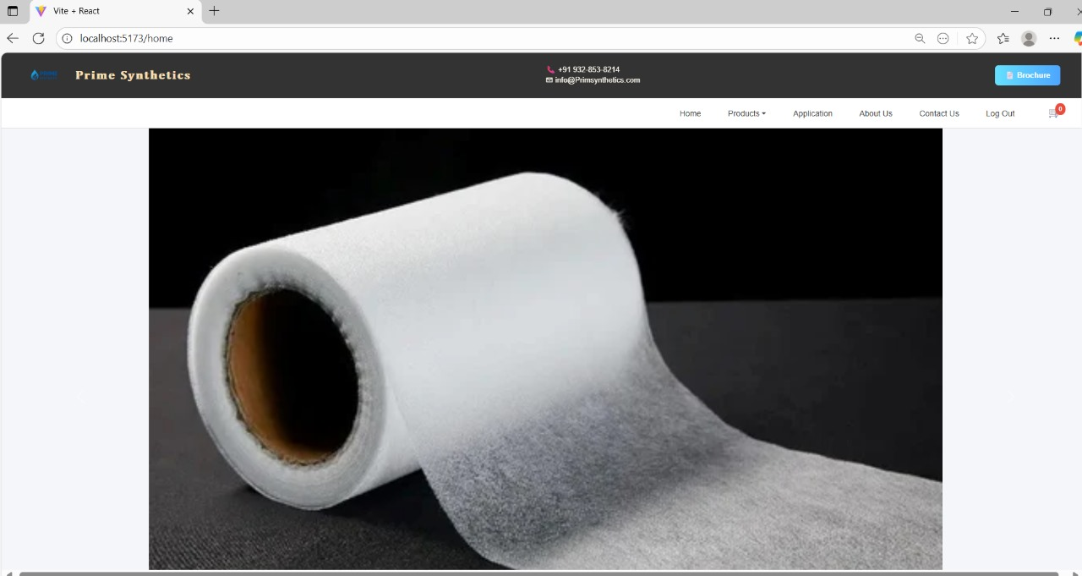

4.Product Page

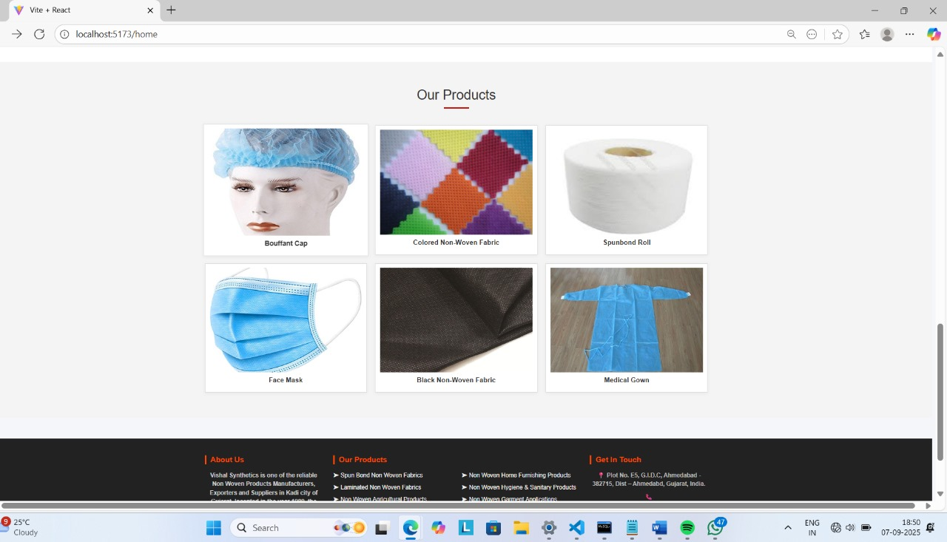

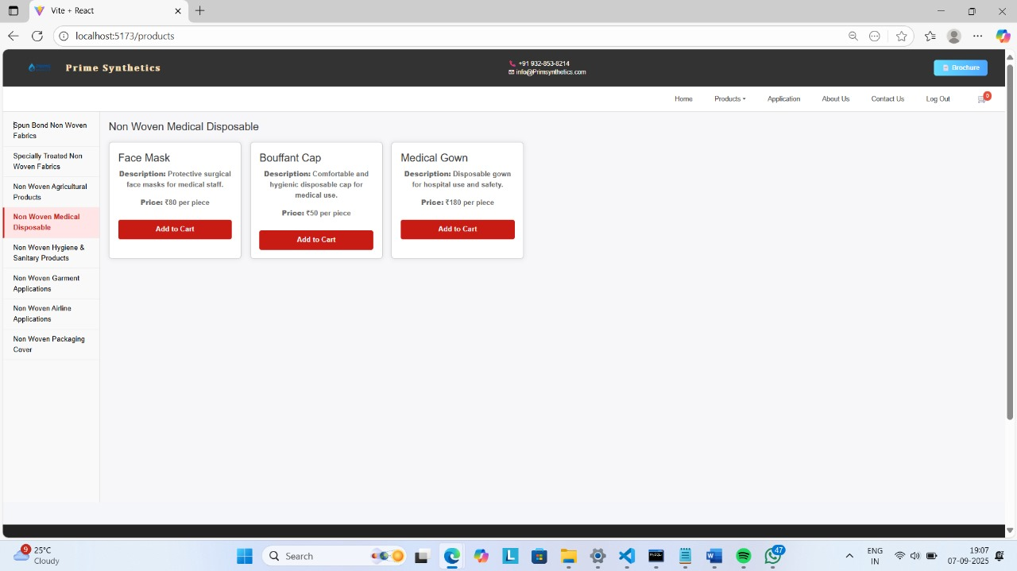

**10. UML Diagram**

**1. Data Flow Diagram**

The system design phase describes the functional

capabilities of the proposed system. This is divided into the following design

phases System dataflow diagram, Input design, processing design and output

design.

As per your System requirement Design 0-level and 1-level

DFD for main module’s (Main process of your project) of the system.

**Represent a Data Store**

**Represent An Entity**

**Represent A Process**

**Represent Data Flow**

* **DFD Level-0**

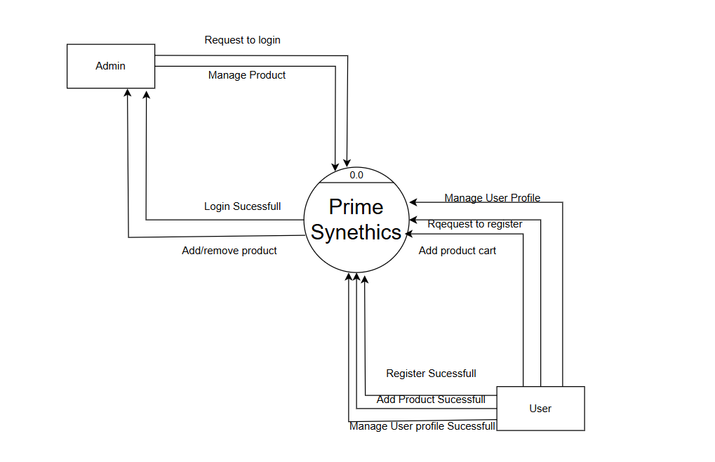

* Level 1(Admin)

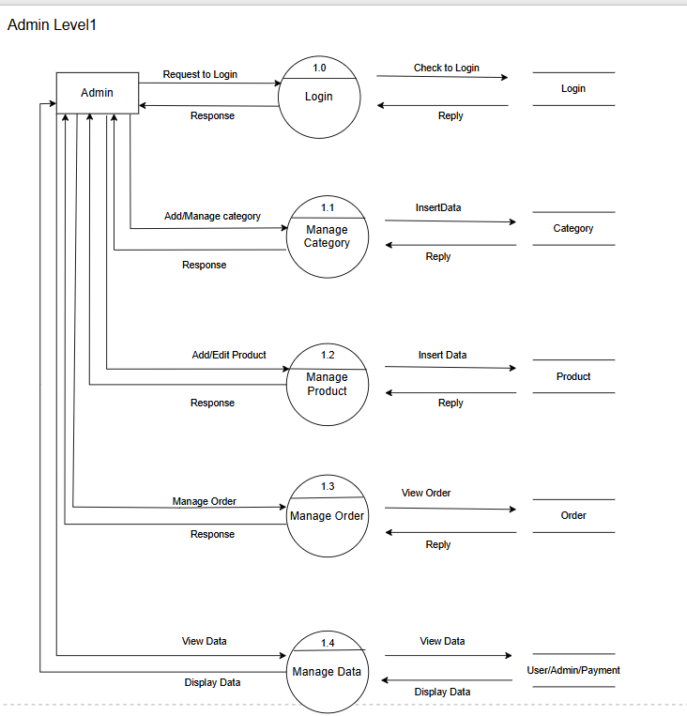

* Level 1(User)

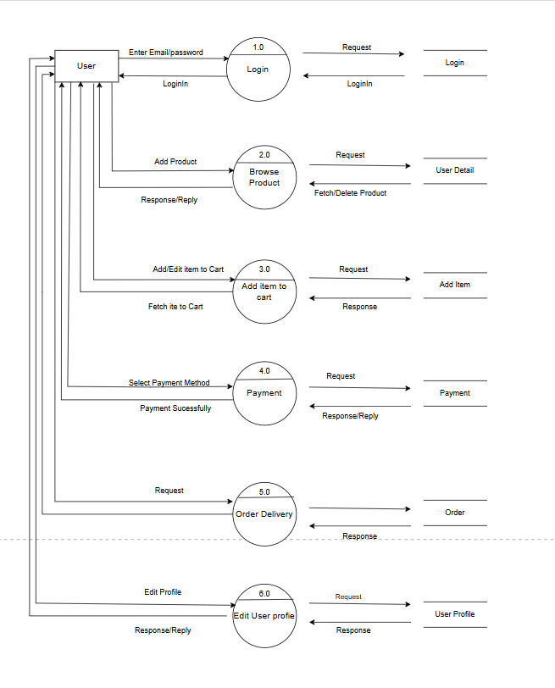

* Usecase Diagram(Admin)

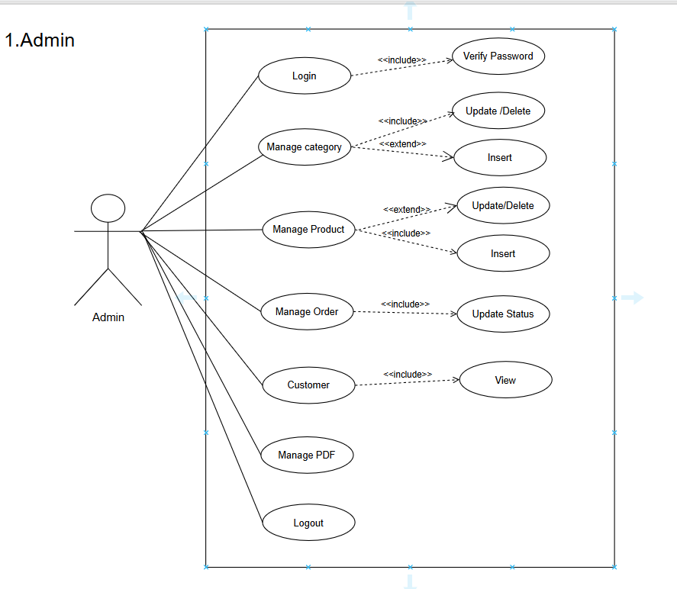

* Usecase Diagram(user)

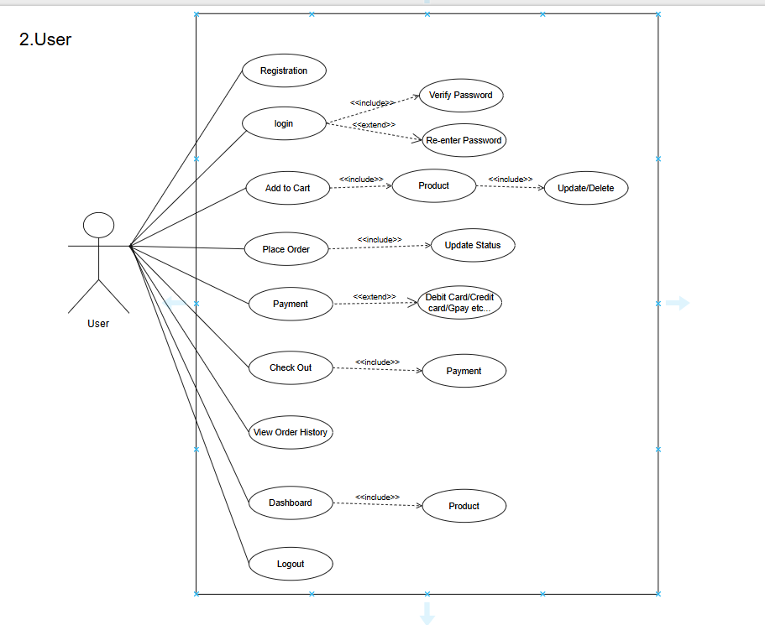

* Class Diagram

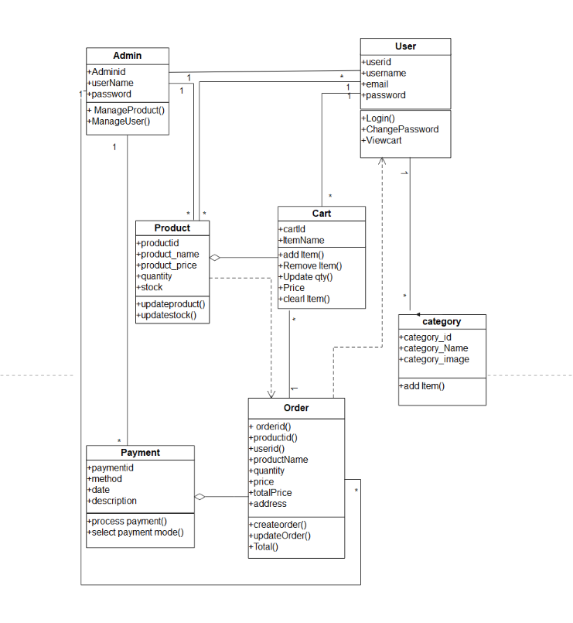

* Activity Diagram(Admin)

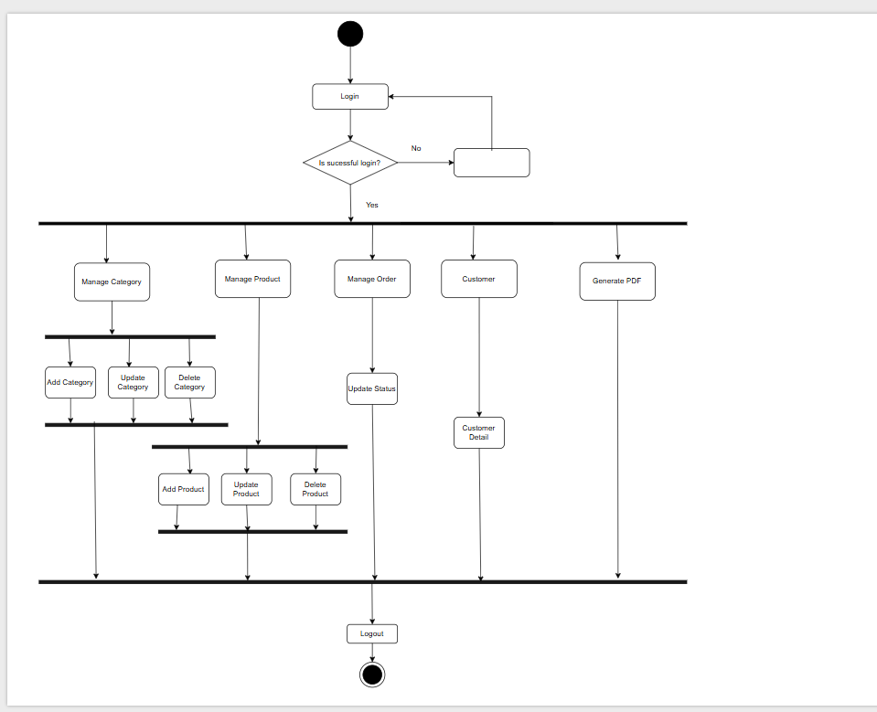

* Activity Diagram(user)

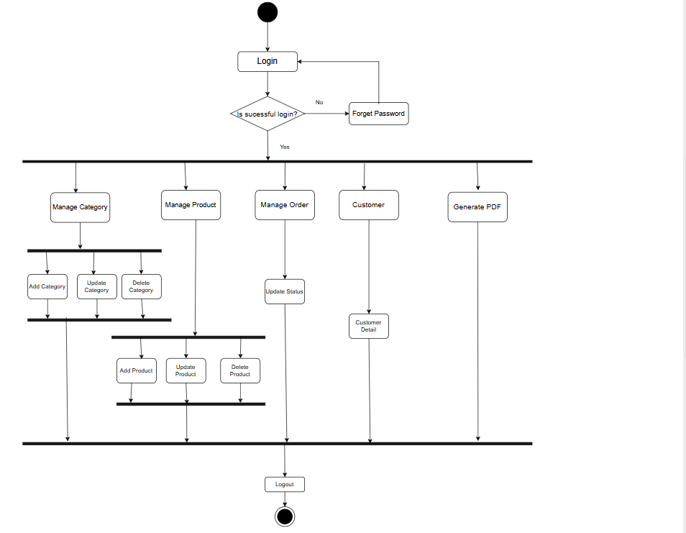

**11.Data Dictionary**

* User Table

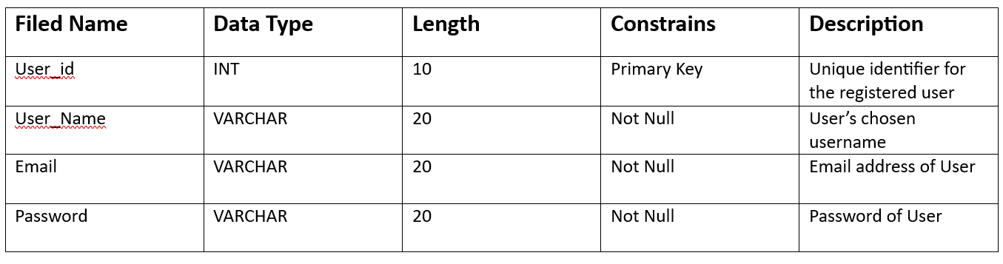

* Admin Table

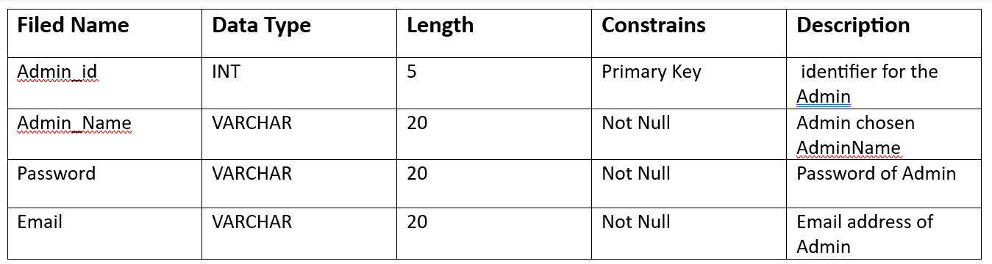

* Product Table

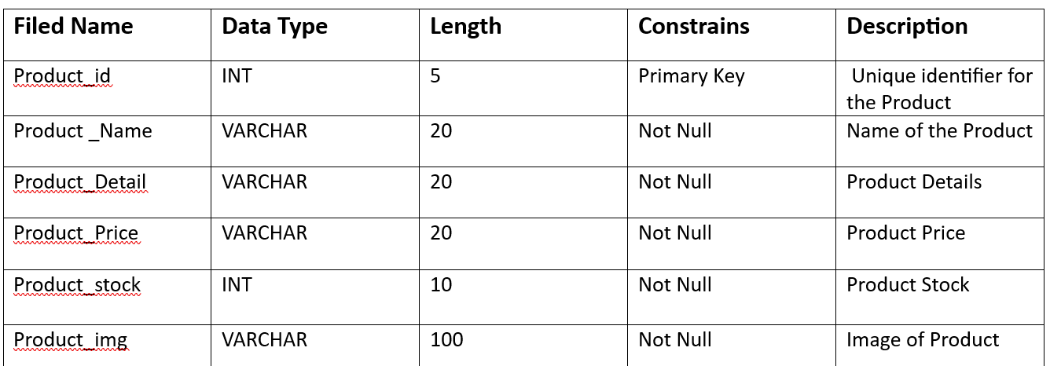

* Category Table

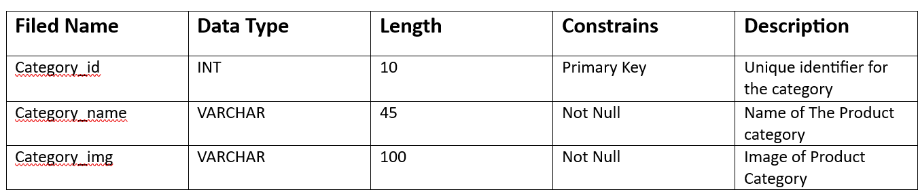

* Order Table

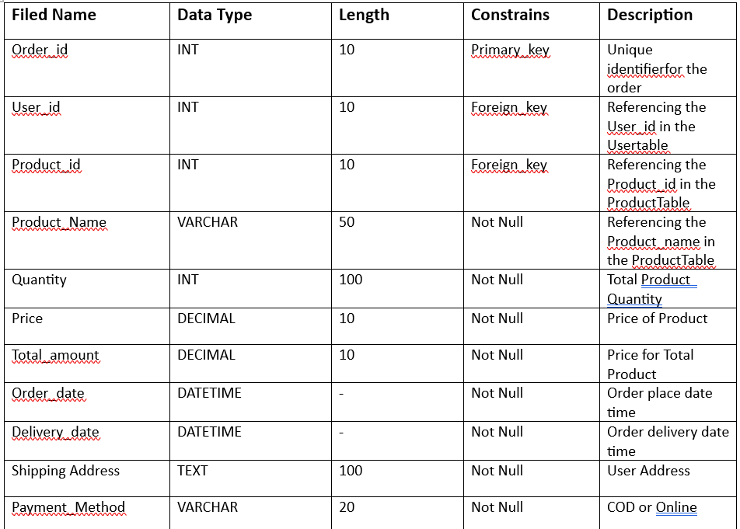

* Cart Table

